We Can Boost Your Personal Credit Score by 200+ Points by Rapidly Repairing Your Credit Profile – GUARANTEED – Or You Don’t Pay!
Yes, We GUARANTEE to Get Your FICO SCORE Boosted by 200+ Points Using Our “Unorthodox Trifecta” Credit Repair Secret…
Or Your Money Back!





“When I was in college, I didn’t respect credit so I ruined my credit rating. I wanted to start a home music studio and needed a loan for the equipment. Thanks to you, I got the loan I needed!”


Don’t Let Poor Credit Hold You Back from Your Dream Car, Dream House, or Dream Job ANYMORE – Act Now!
“No thanks to my ex-husband, I found myself with the worst credit I’ve ever had after the divorce. But you fixed it all in less than a year!”

“I went from a 583 to an 802 FICO score in a matter of months. I’m still surprised at how fast you fixed my personal credit.”
Gabe M.
Went from 528 to 731 FICO
Get Started NOW:

Phyllis D.
Went from 479 to 712 FICO

Leslie O.
Went from 583 to 802 FICO

“I thought my credit situation was hopeless until I found you guys. My life has completely changed, thanks to you!”
CLICK HERE



“My credit was compromised due to identity theft and I stayed up nights worrying about how it damaged my credit. Thanks to you it’s fixed as if it never happened.”
Terry R.
Went from 381 to 686 FICO
Harvey L.
Went from 517 to 746 FICO
Peter K.
Went from 646 to 850 FICO
“I got into a work accident and couldn’t pay my bills. My perfect credit went down the tubes within mere months. Thanks to your service, it’s 100% back on track now.”
Hundreds of Our Clients Went from Low to High Personal Credit FICO Scores in 12 Months or Less!
How We Use an UNORTHODOX Method for Repairing Credit and Permanently Removing Negative Accounts at Lightning Speed

M
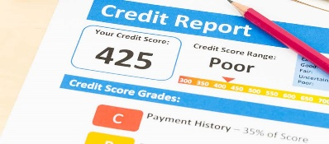
BEFORE
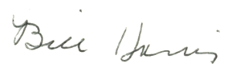

y name is Bill Harris and it wasn’t but a short time ago when I found myself up a creek without a paddle. I had lost everything in the crash of 2008, including my house, and found myself in bankruptcy court after I lost my business because the economy went to hell in a handbasket.

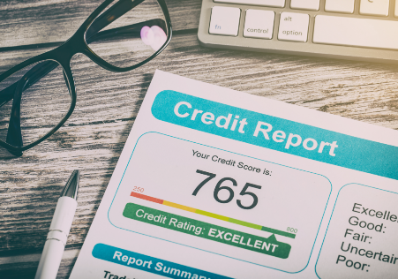
To make matters worse, I couldn’t even qualify for a “beater mobile” at a shady corner used car lot because my credit was so bad. Yes, I was rejected for a loan…even at a laughable 29.9% interest rate on a overpriced used 13-year-old Toyota Corolla. Believe it or not, it wasn’t that long ago when I couldn’t even qualify for a piece of junk car!
I thought I was completely ruined until quite by accident that I discovered a little-known unorthodox secret to quickly fixing my personal credit that MOST people have NEVER heard of! I’m not going to tell you where I found this secret but I will tell you this: my credit repair strategy is UNORTHODOX and “barely legal” but it works…and it works FAST!
Bill Harris
Why is it “unorthodox” and “barely legal”? It’s because I do something that most people never do. I use my “trifecta” credit repair strategy that does three (3) things all at once: (1) challenges negative accounts on each credit report (Experian, Equifax, and Transunion), (2) file government complaints with specific state and federal government agencies, and (3) use an attorney letter to both the credit bureaus and creditors. And we can do ALL this for you!
Now, I will warn you if you want to try to do this yourself: one little misstep, one little error and NONE of your credit repair efforts will work out in your favor. They will fall dead flat and, in some instances, your mistakes can “reset” your debt back to Day One. This means that if you are dealing with old debts that may fall off at the 7-year mark, a credit repair mistake on your part will reset the debt as if today is the first day of 7 years! And that really sucks!
Why take a risk and try to repair your credit yourself when you can use our successful credit repair service to have negative accounts PERMANENTLY REMOVED from your credit reports within the shortest amount of time possible? We GUARANTEE our work. Your FICO score WILL increase by 200 or more points…OR YOU GET A FULL REFUND!
Get Started Right Now and Download Bill Harris’s PROVEN WEALTH BUILDING SECRETS SHARED IN
CREDIT MILLIONAIRE

